Weekly Task for Green Dinosaurs and Blue Dolphins (16:02:2021)
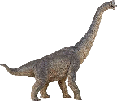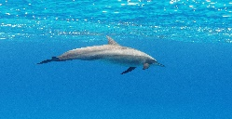
Hello everyone! We hope you have had a wonderful holiday and have had lots of fun playing in the snow. We would love to see your photos and hear all about what you have been doing – email them to us and we will put them into your learning profiles.
SCIENCE/ENVIRONMENT IDEAS
Spring is nearly upon us and the birds are beginning to build nests. Here are some ideas to give them a helping hand;
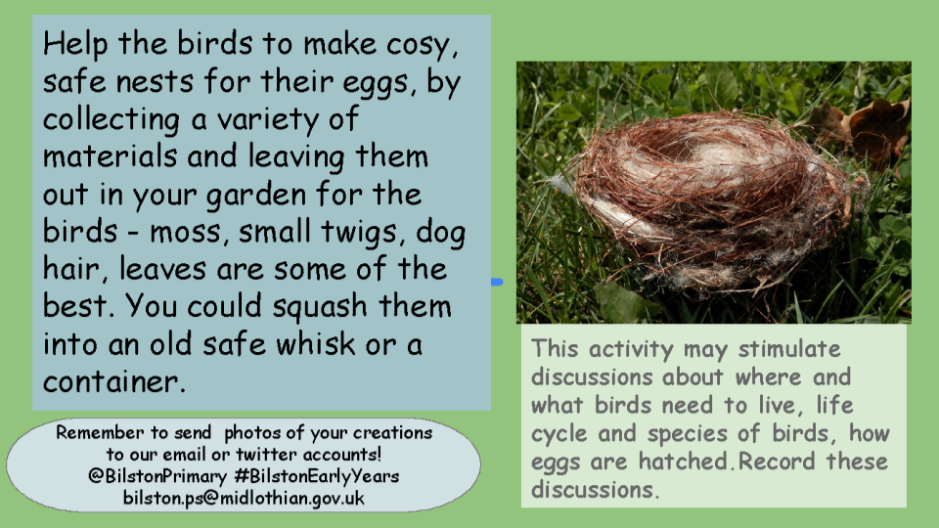

LITERACY
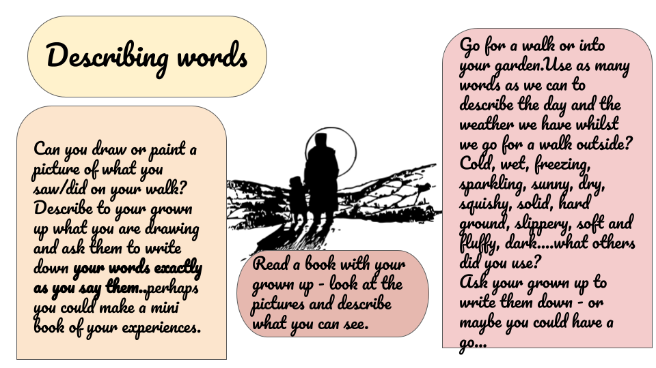

HEALTH AND WELLBEING
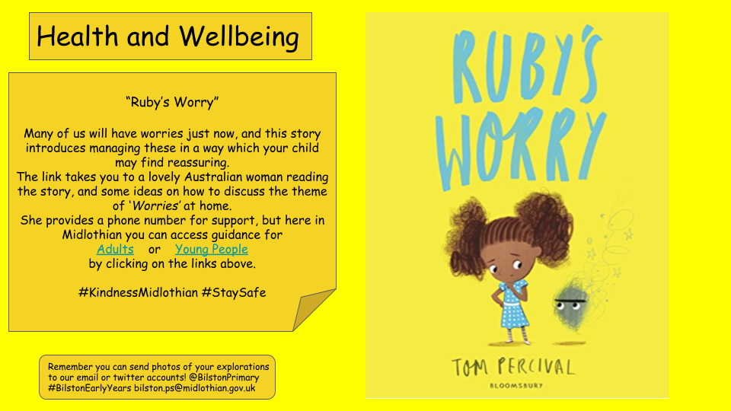
We hope you enjoy these activities and look forward to seeing what you do with them. Don’t forget to share them with us at;
Email: bilston.ps@midlothian.gov.uk
Twitter: @BilstonPrimary use the hashtag #BilstonEarlyYears
Have a great week and hope to see you all very soon!
Mrs Marwick and Miss O’Hara

