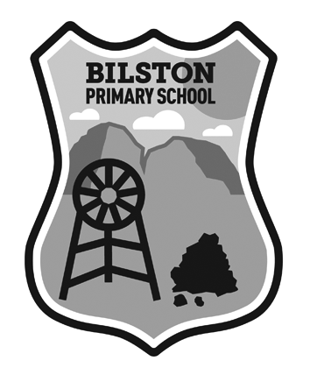 | BILSTON PRIMARY SCHOOL  PARK AVENUE  BILSTON  MIDLOTHIAN EH25 9SD  Telephone 0131 444 9021  Mrs Sheryl Wallace  Head Teacher

18th April 2018

Nursery, P1 & P2 pupils

Dear Parent/Carer

We have the Clydebuilt Puppet Theatre coming into school to perform Rapunzel on Friday,
4th May 2018 at a cost of £4.60 per child.

It starts at 9.45 am so the afternoon Nursery children are invited to attend in place of the Friday afternoon session that week.

Please complete the tear-off slip below.

Yours sincerely

Sheryl Wallace
Head Teacher

Clydebuilt Puppet Theatre – Rapunzel

Name of child(ren) _______________________________

Class (es) ____________________________

I enclosed £4.60 per child towards the cost

Signed ___________________________________ Date ___________________

